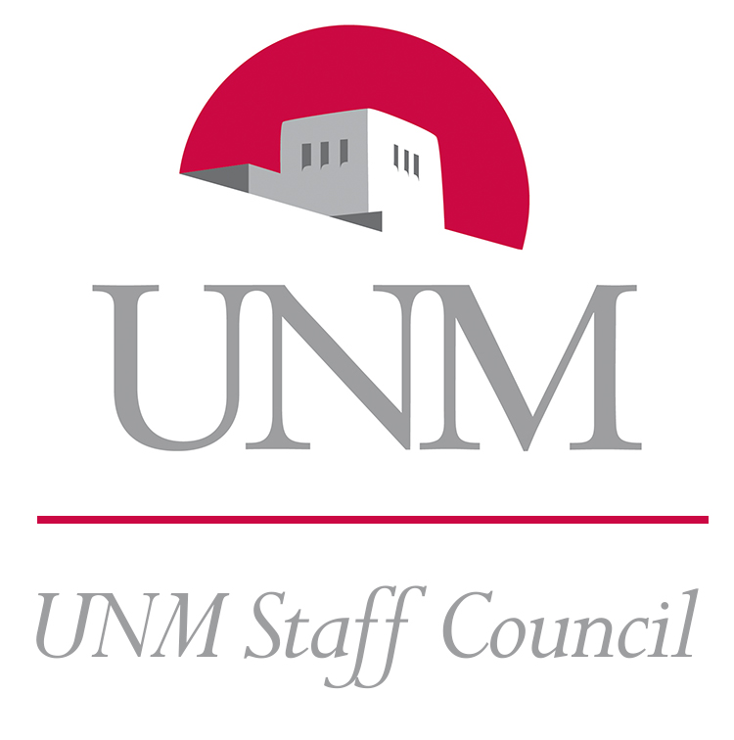 | Staff Council Standing Committee Minutes  Committee Name: Communications & Marketing  Meeting Date and Place: March 17, 2016 – 3:00-4:00 pm, University Club  Members Present: Josh Clifford, Susy Salvo-Wendt, Lisa Walden  Members Excused: Marjorie Crow, John Byram  Members Absent: Marcos Abeyta, Lisa Tremaine  Guests Present: None  Minutes submitted by: Josh Clifford

 | Subject | Notes | Follow-Up
1 | Approve Agenda | Approved
2 | Approve 2/18/16 Minutes | Approved
3 | Member Update | Monica resigned this month. One new member starting in April. Another potential member to be referred. | Josh will check up on the status of the additional potential member.
4 | Review 3/1 Meeting with Executive | We reviewed the idea for the communication standards initiative and the meeting about it with Exec the co-chairs had on 3/1. | Josh and Lisa will meet next week to review and do initial preparations.
5 | Communications Standards Initiative | We discussed and brainstormed. | Susy doing form with Engagement and will send through C&M.
 | Next Meeting | The next meeting will be April 21, 3-4pm, at the University Club. | Meeting adjourned (3:55pm)

Communications Committee Roster 2016
Name | Department | Phone | Email
Marcos Chavez Abeyta | IT | 7-5191 | mabeyta@unm.edu
John Byram | UNM Press | 7-3280 | jbyram@unm.edu
Josh Clifford (co-chair) | Psychiatry Research | 925-4344 | jcliff89@gmail.com, jcliff@unm.edu
Marjorie Crow | Art & Art Hist. | 7-5861 | mcrow@unm.edu
Susy Salvo-Wendt | Neurosurgery | 2-4280 | ssalvo-wendt@salud.unm.edu
Catherine Rivera | Continuing Medical Ed | 2-6569 | crivera1748@salud.unm.edu
Lisa Tremaine | UNM Press | 7-3333 | ltremaine@unm.edu
Lisa Walden (co-chair) | Bookstore | 7-7494 | lwalden@unm.edu

